Batch_DOIT_Normalised_Ratio

DESCRIPTION: This program calculates normalised ratios of the form:

(BAND - BAND) / (BAND + BAND)

The user may choose to calculate one or more of the following indices:

NDVI = (NIR - R) / (NIR + R)

NDWI 1 = (NIR - MIR) / (NIR + MIR)

NDWI 2 = (G - NIR) / (G + NIR)

mNDWI = (G - MIR) / (G + MIR)

The user must define each input band in the selected indices.

This program operates in batch mode by date. For each unique date the selected
indices are calculated and saved to file.

NOTES: This program calls one or more external functions. You will need to compile the
necessary functions in IDL, or save the functions to the current IDL workspace
prior to running this tool.

To identify the workspace (CWD) run the following from the IDL command line:

CD, CURRENT=CWD & PRINT, CWD

Functions used in this program include:

FUNCTION_WIDGET_Date.pro
FUNCTION_WIDGET_Droplist.pro
FUNCTION_WIDGET_No_Data.pro
FUNCTION_WIDGET_Select_Ratio.pro
FUNCTION_WIDGET_Set_Bands.pro

For more information contact Garth.Warren@csiro.au

INPUT:

1. Select the Input data: One or more single band date-sets.

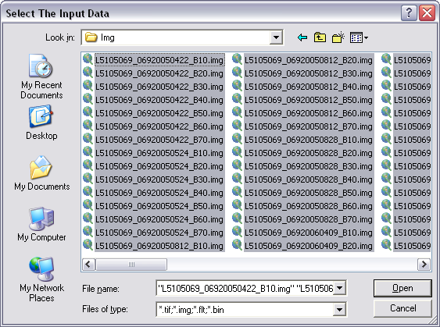
2. Define Dates: A multi-part widget; select a filename from the list and set the position of the first character in the DOY and Year, or Day, Month and Year strings. The selected date parts are printed at the bottom of the widget.

An invalid selection will cause the program to quit. For more information see FUNCTION_WIDGET_Date.pro

- Guy, set the date as below. It should be the same positions for all Glovis Landsat 5.

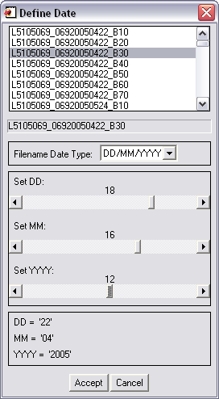

3. Select the input data type: Select the input data type from the droplist. An incorrect data type selection will result in invalid results.

- Set the data type as BYTE.

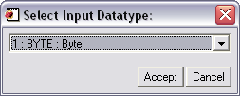

4. Define No data: if the input data has a no data value that you want ignored in the ratio calculation select 'Set a Grid Value to NaN' and define the value in the text box.

- Set ‘Do Not Set a Grid Value to Nan’

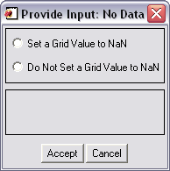

5. Select Indices: Select one or more indices. The program will calculate and write the selected ratios. You must select at least one index.

- Select NDVI and NDWI1 as shown.

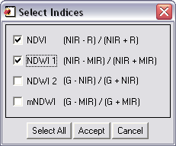

6. Define Bands: You must assign the correct input files to the correct band for the program to calculate the selected indices correctly. Select an input file from the file list, select the reflectance band associated with the input file. Using the sliders set the string in the selected filename that defines the band.

For example, the input file 'L5105069_06920060730_B30' contains landsat 5 reflectance data for band 3 which is the Red band. Select 'Red Band' from the band list. Change the 'Length: Red' slider to 3, and move the 'Position: Red' to 21. The red string displayed at the bottom of the widget should display 'B30'. With this information the program can search and extract all of the red band data files from the input file list.

- See the following set of pictures. First define the red band by selecting a file that has the suffix B30 (as below). Then select ‘Red Band’ from the band list (see the following pic.). Move the sliders to the correct positions (see pic 3). Repeat for the NIR and MIR bands (see pic 4) then click ‘Accept’

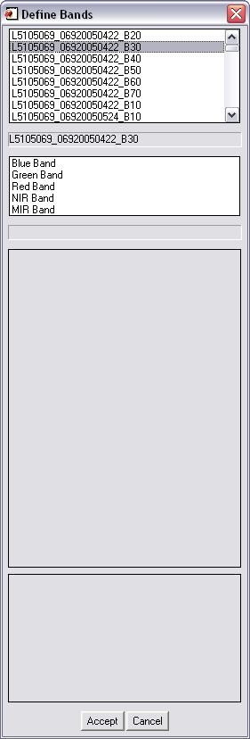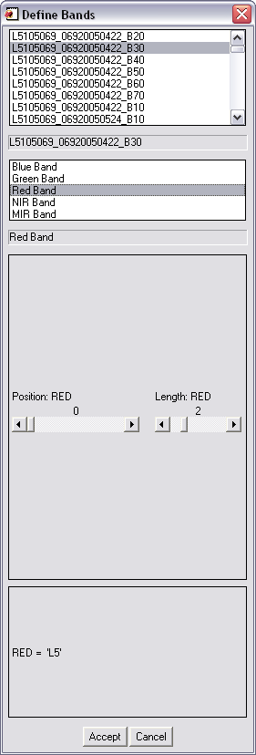

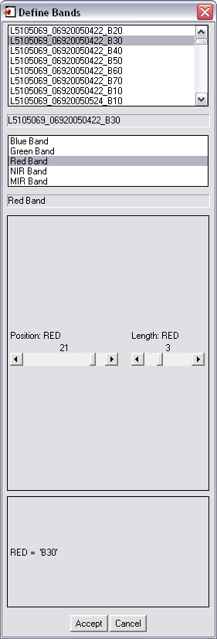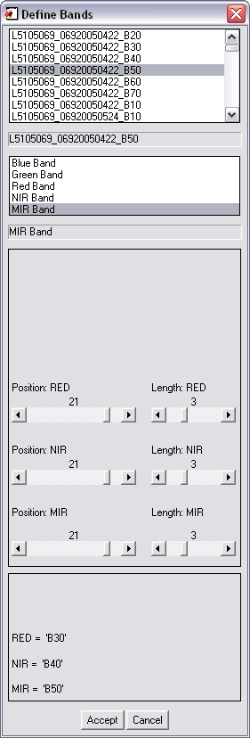

7. Select the output folder.

